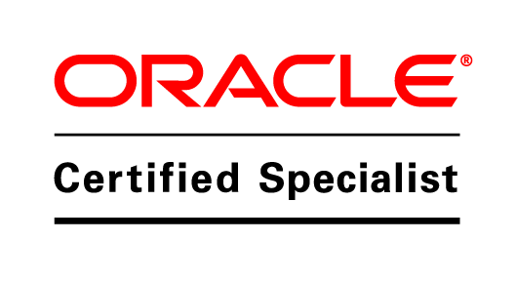

**Pranita Lohkare**

**Email :** **lpranita11@gmail.com**

**Current contact numbers:** +918793537987

**Summary:**

|  |
| --- |
| * 3.2 years of experience as an Oracle Application DBA * Worked on various versions of Oracle Applications on different Operating Systems in a 24x7 environment and provided Production support. * Strong Analytical and troubleshooting skills along with communication skills * Experienced on all the Oracle Apps DBA related functions – Monitoring, Cloning, Patching and Troubleshooting Apps/DB issues in a 24x7 environment. * Experienced with cloning of Oracle Application from Production to Test, Dev * Applied Application patches and database patches with adpatch, Opatch utilities. * Experienced in taking Backups using RMAN. * Handled Applications configuration using Autoconfig. * Experienced in System Administration activities like – defining Concurrent programs, Request sets, Profile settings, Printer settings, concurrent managers, workflows, troubleshooting CM issues and User/Responsibility management. * Worked with various Oracle Applications Utilities like AD Administration, AD Controller, Autoconfig, AD Merge Patch, AD Relink, AutoPatch, Rapid Install, FNDCPASS, and FNDLOAD etc. * Managing multiple environments like Production, Development, and Test of different releases. * Checking the status of important services like concurrent manager, forms server, web server, application listener and database listener is up. * Worked on shell script to automate task. |

**Skills Profile:**

|  |  |
| --- | --- |
| **ERP** | EBS 11i,R12, R12.2 |
| **Language** | SQL, Shell Scripting |
| **Database** | Oracle 11G, 12c |
| **Operating Systems** | Red Hat Linux 6, IBM AIX. |

**Educational Qualification:**

|  |
| --- |
| Bachelor of Engineering in Information Technology |
| Oracle Database 12C Essential Certified |

**Experience:**

|  |  |
| --- | --- |
| **DBA Shared Services (DSS)** | |
| **Objective** | 24x7 supports for Production and Non-Production instances and resolve any issues within the SLA. |
| **Role** | ORACLE Application DBA |
| **Client** | * Multiple clients (approx. 10) in U.S. and U.K (CAFOS, UGN, KAG, Fellowes, Vitamix, Welchs, ) |
| **Environment** | * Oracle Applications, Oracle Database, Red Hat Linux |
| **Products** | * Oracle EBS 11i and R12, Oracle Database 11G and 12c. |
| * Was a part of 12 member team which was responsible for 24x7 support. * Creating Users, Responsibilities, Site level profiles from front end. * Scheduling & Trouble shooting Concurrent Request & Managers. * Database administration of production and test instances. * Cloning of oracle applications using Manual & Rapid clone. * Worked with AD utilities -adadmin, adctrl, adpatch for maintenance. * Applied application patches using adpatch and troubleshooting patch issues. * Troubleshooting the Login issues relating to Oracle HTTP Server, * Working with online support from Metalink for solving critical oracle errors * Proficient in Code migration across the instances like forms, reports, Concurrent programs using FNDLOAD. * Monitoring/Freeing File System space based on mail alert, Tablespace free space based on email alert. * Monitoring memory and CPU utilization and always tried to avoid performance bottlenecks. * Responsible for day-to-day administration of various Oracle Applications environments. | |
| **Toyota Boshoku America** | |
| **Objective** | 24x7 supports for Production and Non-Production instances and resolve any issues within the SLA. |
| **Role** | ORACLE Application DBA |
| **Client** | Toyota Boshoku, one of the world’s premium interior systems suppliers and filter manufacturers, develops and produces interior, filtration, and powertrain components. |
| * Applied Application patches and database patches with adpatch utilities. * Creation of synonyms, Rebuilding of indexes and Table reorg. * Automate the task using shell scripting * Handling this project as dedicated Oracle DBA. * Managing multiple environments like Production, Development, and Test of different releases. * Cloning of Oracle Application from Production to Test, Dev. | |

**Personal Details:**

|  |  |
| --- | --- |
| **Name :** | Pranita Lohkare |
| **Nationality:** | Indian. |
| **Sex :** | FEMALE |
| **Date Of Birth :** | 11TH NOVEMBER, 1991 |
| **Languages Known** | English, Hindi,Marathi. |

I hereby declare that above information is true & correct up to best of my knowledge and can be supported with relevant documents.

Place: Pranita Lohkare